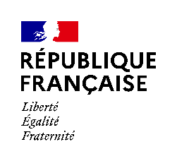 |  |  | 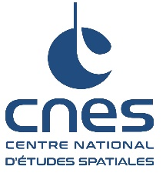
23 february 2026 |  | 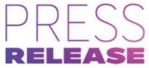 |  | PRXXX-2026
Cercle, ESA and CNES announce a historic partnership at The Musée de l’Air et de l’Esapce – Paris-Le Bourget
for Cercle Festival 2026

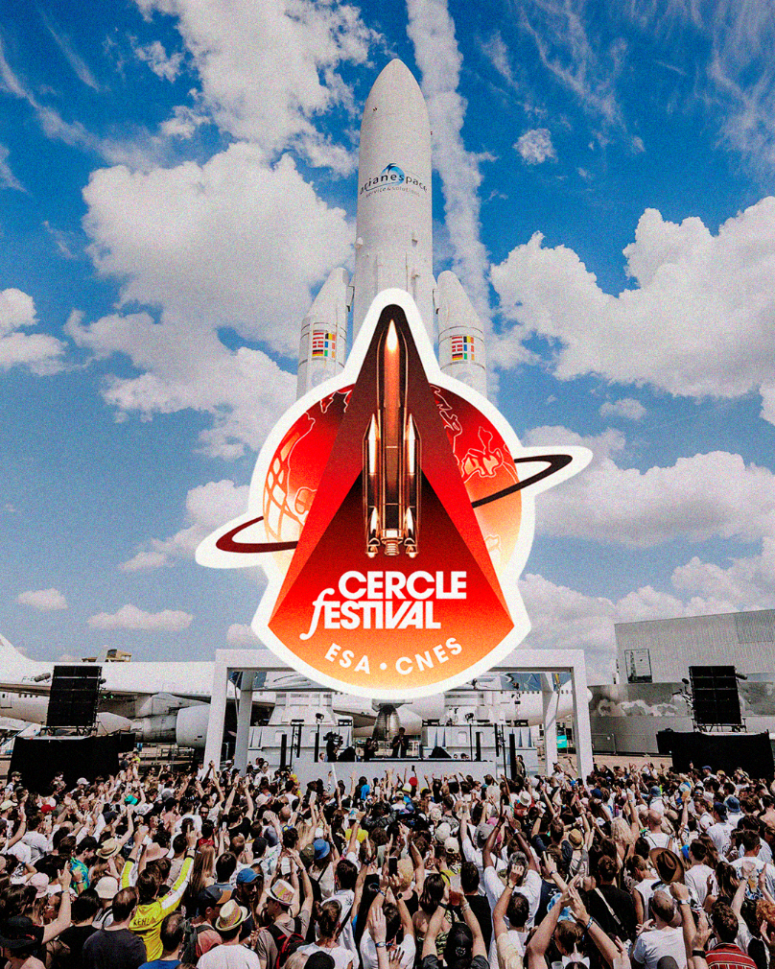

The European Space Agency (ESA), the French National Centre for Space Studies (CNES) and Cercle today announce an unprecedented collaboration for the 2026 edition of Cercle Festival, bringing together for the first time the French and European space agencies with one of the world’s most distinctive electronic music festivals.
Set to take place from May 22–24, 2026, at the Musée de l’Air et de l’Espace – Paris-Le Bourget, this collaboration embodies a shared vision that brings together innovation, exploration, knowledge sharing and artistic creation at the heart of an iconic site in aeronautical and space history.
Music and space: a historic relationship
Far more than an institutional partnership, this collaboration is part of a longstanding artistic dialogue between music and space. From the cosmic imaginaries explored by David Bowie and Pink Floyd during the era of the space race, to electronic music pioneers such as Jean-Michel Jarre, Kraftwerk and Daft Punk, space has consistently fueled sonic and visual experimentation.
Through its synthetic textures, immersive sound design and futuristic aesthetic, electronic music naturally evokes the vastness of the cosmos and the spirit of exploration. Cercle Festival thus becomes a unique platform where space, science and contemporary creation converge.
Set on the legendary Le Bourget tarmac, surrounded by aircraft and Ariane launchers, the festival will place aeronautical and space heritage at the heart of forward-looking musical and audiovisual experiences.
An alliance between space, science and contemporary culture
Through this partnership, ESA and CNES are investing in a new cultural territory to share the key challenges of the French and European space sectors with an international, curious and intergenerational audience. Dedicated activations will highlight the tangible role of these space activities, with a focus on science, exploration and access to space.
This collaboration reflects the shared ambition of ESA and CNES to build new bridges between science and culture by engaging with new audiences beyond traditional institutional frameworks.
An iconic setting for an unprecedented edition
Renowned for transforming exceptional locations into spectacular musical stages, Cercle will once again take over the tarmac of the Musée de l’Air et de l’Espace – Paris-Le Bourget for its festival.
Three iconic stages will be set beneath landmarks of aeronautical and space history:
- A380 Stage
- Concorde Stage
- Ariane Stage
These spaces will host international artists, including Eric Prydz, ARTBAT, Ben Böhmer, ANNA, Kölsch, Lane 8, Michael Bibi and Adriatique, alongside emerging talents and a global community, in a scenography designed to elevate both the music and the surrounding architecture and heritage.
Following a sold-out 2024 edition that welcomed audiences from more than 100 countries, the 2026 edition will expand to three days, further reinforcing Cercle Festival’s international reach and artistic ambition.
An immersive space dome at the heart of the festival
At the center of the experience, ESA, CNES and Cercle will unveil a first-of-its-kind installation in a European music festival: an immersive space dome designed as a hub for discovery and experimentation. The venue will host thematic talks bringing together astronauts, experts and leading scientific figures (line-up to be announced soon), a space models exhibition, and immersive experiences including virtual reality and sensory installations.
A symbolic opening from space
Among the highlights of this collaboration is the participation of Sophie Adenot, ESA astronaut currently aboard the International Space Station as part of the εpsilon mission.
She will officially open Cercle Festival 2026 through an exceptional address recorded in microgravity from the International Space Station (ISS), creating an unprecedented moment of connection between Earth, space and music.
Further details on the partnership and programme will be announced soon.

About Cercle
Cercle is an artistic movement that creates and produces immersive experiences, events, festivals, a music label, and unique musical journeys. At the crossroads of music, aesthetics, heritage, and image, Cercle shines a spotlight on unique artists performing in extraordinary settings, offering a new perspective on the world’s cultural and natural legacy. To date, Cercle has produced more than 240 events across the globe, including around thirty in UNESCO Heritage sites.
CERCLE FESTIVAL 2024 IMAGES & VIDEOS
CERCLE FESTIVAL: INSTAGRAM / TIK TOK / FACEBOOK
CERCLE MUSIC SPOTIFY / YOUTUBE
PRESS CONTACT : jimena@cerclemusic.com

About ESA
The European Space Agency (ESA) is Europe’s gateway to space.
ESA is an intergovernmental organization founded in 1975, whose mission is to shape the development of Europe’s space capabilities and to ensure that investments in space benefit European citizens and the world as a whole.
ESA has 23 Member States: Austria, Belgium, the Czech Republic, Denmark, Estonia, Finland, France, Germany, Greece, Hungary, Ireland, Italy, Luxembourg, the Netherlands, Norway, Poland, Portugal, Romania, Slovenia, Spain, Sweden, Switzerland, and the United Kingdom. Latvia, Lithuania, and Slovakia are Associate Members.
ESA has established formal cooperation with four EU Member States. Canada participates in certain ESA programs under a cooperation agreement.
By coordinating the financial and intellectual resources of its members, ESA can undertake programs and activities that go far beyond the scope of any single European country. It works in particular with the EU on the implementation of the Galileo and Copernicus programs, as well as with EUMETSAT on the development of meteorological missions.
To learn more about ESA, visit www.esa.int.
PRESS CONTACT : media@esa.int

About the National Air and Space Museum of France
Located at Paris-Le Bourget Airport, this historic museum, founded in 1919, is one of the oldest and most prestigious aeronautics museums in the world. It houses over 150 aircraft and thousands of exceptional objects – satellites, rockets, engines, models and artworks – tracing the human journey of conquering the skies.
PRESS CONTACT : presse@museeairespace.fr

About CNES
CNES (Centre National d'Etudes Spatiales) is the public establishment responsible for proposing French space policy to the Government and implementing it in Europe. It designs and puts satellites in orbit and invents the space systems of tomorrow; it promotes the emergence of new services that are useful in everyday life.
CNES, created in 1961, initiates major space projects, launchers and satellites and is the natural partner of industry for pushing innovation.
CNES has nearly 2,400 employees, men and women who are passionate about space, which opens up infinite, innovative fields of application; it intervenes in five areas: the Ariane launcher, scientific research, observation, telecommunications and defence.
CNES is a major player in technological innovation, economic development and industrial policy in France. It also establishes scientific partnerships and is involved in numerous international projects.
France, represented by CNES, is one of the main contributors to the European Space Agency (ESA).

CONTACTS
Nathalie Blain | Tel. +33 (0)1 44 76 75 21 |  |  |  | nathalie.blain@cnes.fr
Pascale Bresson | Tel. +33 (0)1 44 76 75 39 |  |  |  | pascale.bresson@cnes.fr
Raphaël Sart | Tel. +33 (0)1 44 76 74 51 |  |  |  | raphael.sart@cnes.fr

